**NAME:**ASHWINI.R

**DEPARTMENT:** B.E.COMPUTER SCIENCE AND ENGINEERING

**COLLEGE:** DHANALAKSHMI SRINIVASAN INSTITUTE OF TECHNOLOGY,SAMAYAPURAM,TRICHY.

**NAANMUDHALVAN COURSE:** DIGITAL MARKETING

**NM ID:** 0A8B666D8D88153BE434E1DABD69CD3E

**ASSIGNMENT ON DIGITAL MARKETING**

**1.Create a blog or Website using Blogspot and Wordpress. Customize the theme design and post new article with 500 words**

<https://ashuboutique.blogspot.com/2023/08/boutique-bridal.html>

<https://ashuboutique268.wordpress.com/2023/10/18/different-type-of-bridal-dresses/>

**2.Create a New Facebook Business Page and post one social media poster for**

**your brand.**

<https://www.facebook.com/profile.php?id=61552521213255&mibextid=ZbWKwL>

**3.Create and design a social media advertisement poster using canva**

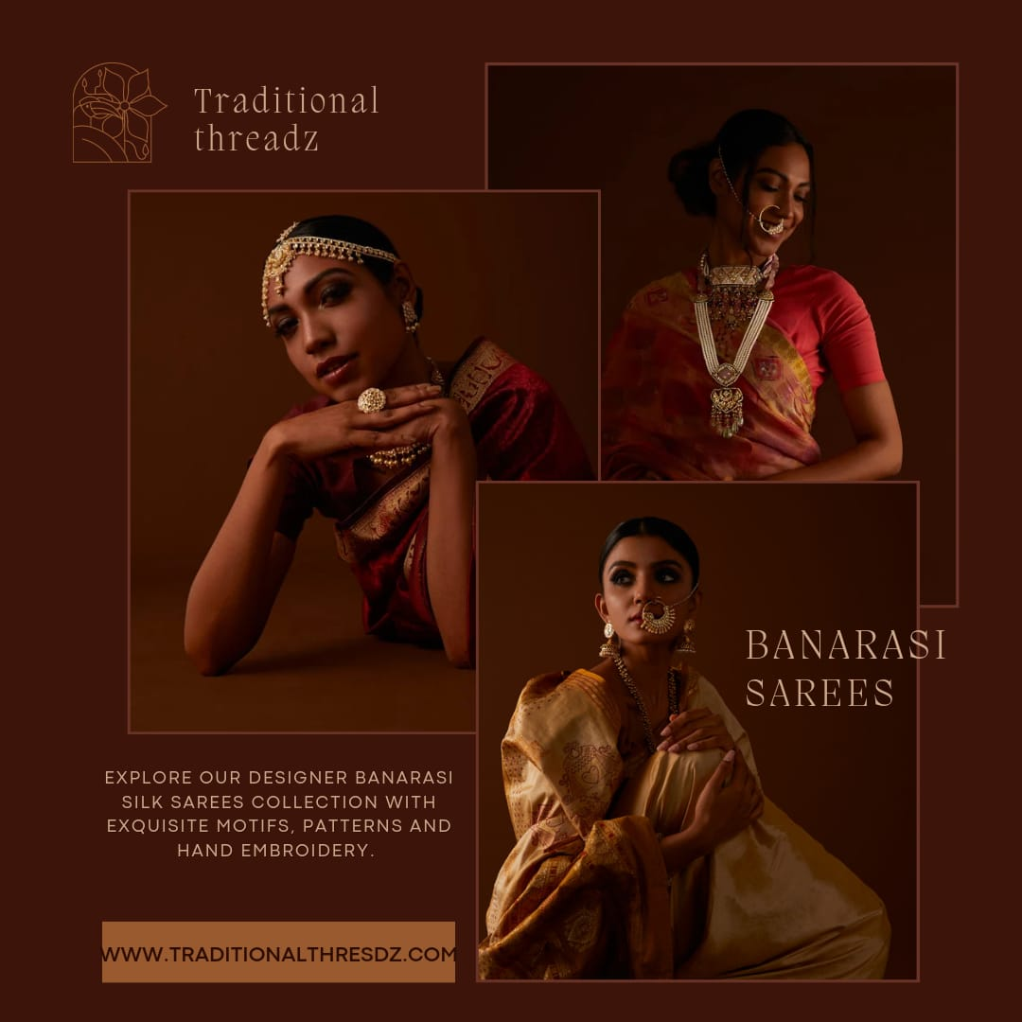

**4.Crete email newsletter design using Mailchimp or canva tool.**

